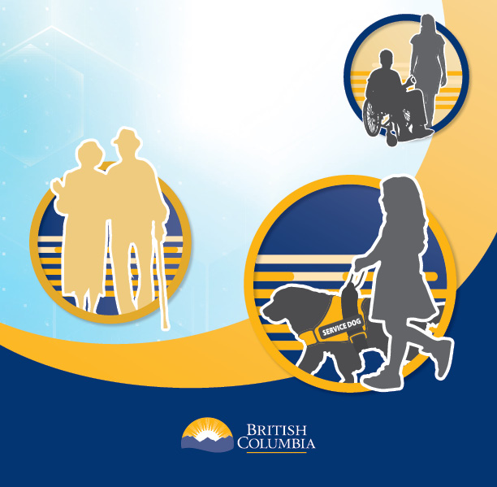

Community Engagement:
Funding Application Form

- Name of Organization
Click or tap here to enter text.

2. Contact Information

Lead applicant name

Address

Phone

Email

3. Brief overview of organization/group

Instructions
- Maximum 200 words
- Provide information about who the organization serves, represents or works with
- Provide information about the scope of service, e.g. province-wide or regional
- Is the organization registered?

4. Accessible Standards Engagement

Instructions
- Total amount requested
- Number of proposed sessions
- Expected total number of participants
- Explain how the funds would enable the group/organization to support meaningful feedback and input on the draft accessibility standards from the identified priority populations or people living with disabilities or experiencing barriers to service and employment.
Click or tap here to enter text.

- Provide a breakdown of how the funds will be used
For example, how much funding will be used for food/refreshments, space rental, translations, etc.

- Do you commit to submitting a written report?

☐ Yes
☐ No

Please note application will be processed on a first come, first served basis until funds are expended.

