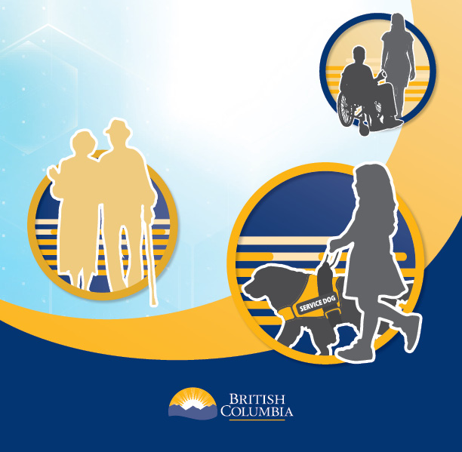

Indigenous Engagement:
Funding Application Form

1. Name of First Nation, Métis Chartered Community, organization or association

2. Contact Information

Lead applicant name

Address

Phone

Email

3. Indigenous organization or association information:
Required for organizations and associations only

Instructions
- Provide information about who the organization serves, represents or works with.
- Provide information about the scope of service, e.g. province-wide or regional.
- Is the organization registered?

4. Accessible Standards Engagement

Instructions
- Total amount requested
- Number of proposed sessions
- Expected total number of participants
- Explain how the funds will be used to support engagement with members of the Nation, community, organization or association:

- Provide a breakdown of how the funds will be used
For example, how much funding will be used for food/refreshments, space rental, translations, etc.

- Do you commit to submitting a written report?

☐ Yes
☐ No

Please note application will be processed on a first come, first served basis until funds are expended.

